Screenshots

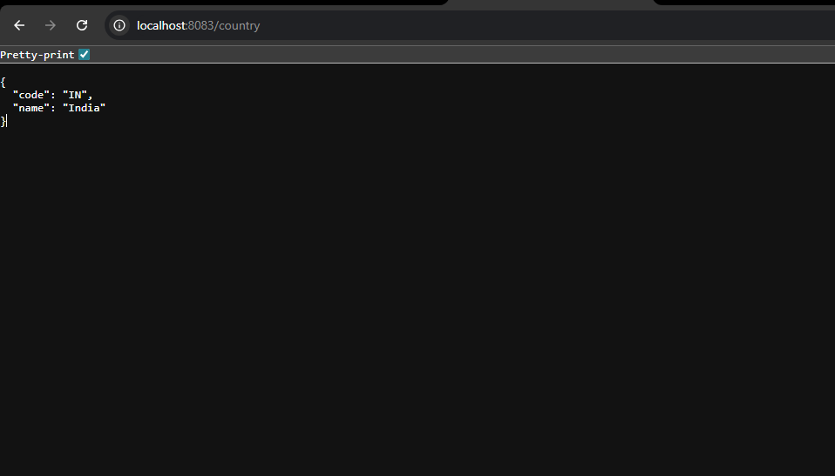

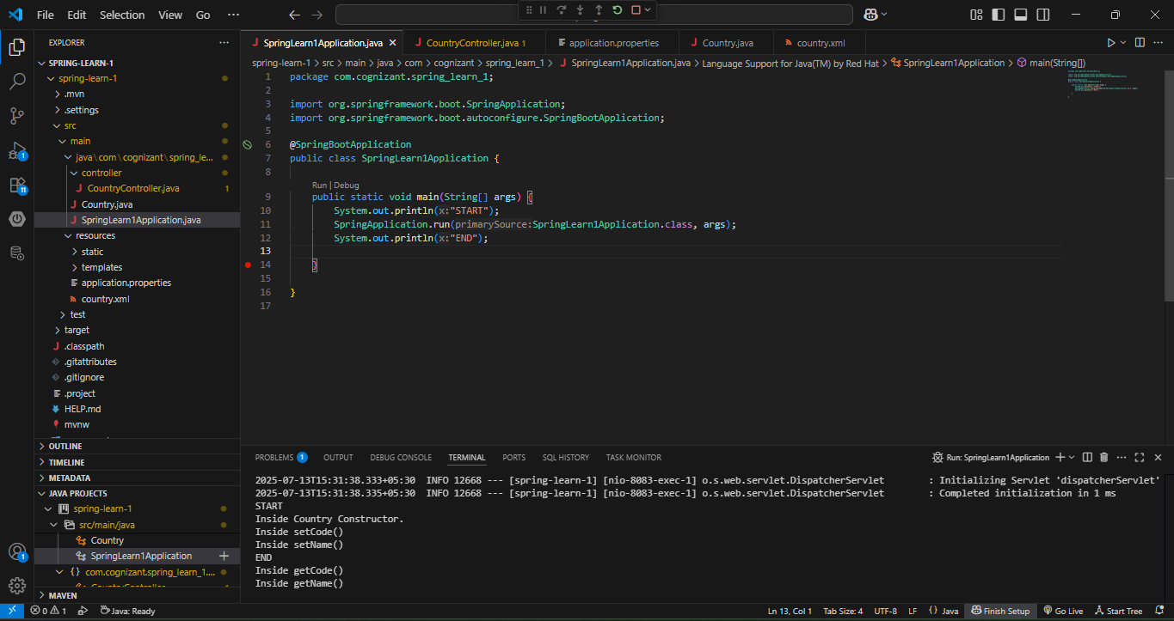

# 🌍 REST API to Return India Country Details (Spring Learn)

## 📄 Description

This Spring-based RESTful web service returns details of **India** using the country bean defined earlier in the Spring XML configuration file (`country.xml`). The data is exposed as a JSON response through a REST endpoint.

This assignment demonstrates the integration between:

- XML-based Spring bean configuration

- Spring Web’s `@RequestMapping`

- Jackson’s automatic object-to-JSON conversion

### ✅ Endpoint Details

| Method | URL | Response (JSON) |

|--------|---------------------------|----------------------------------|

| GET | `http://localhost:8083/country` | `{ "code": "IN", "name": "India" }` |

### 🧩 Controller Implementation

- **Package**: `com.cognizant.spring_learn.controller`

- **Class**: `CountryController`

- **Method**: `getCountryIndia()`

- **Annotation**: `@RequestMapping("/country")`

- **Logic**:

- Loads the Spring context using `ClassPathXmlApplicationContext`

- Retrieves the `country` bean defined in `country.xml`

- Returns it as a response (automatically converted to JSON)

### 📦 Spring Bean (country.xml)

```xml

<bean id="country" class="com.cognizant.spring_learn.model.Country">

<property name="code" value="IN" />

<property name="name" value="India" />

</bean>